HDOC-6
PROBLEM STATEMENT: ·
Question 1:
Write a C program to find the total area of a rectangle with a semicircular end when the rectangle length, rectangle breadth, and semicircle radius are given.
Question 2:
Write a C program to find the total area of a combined figure made of a triangle and a rectangle when the triangle base, triangle height, rectangle length, and rectangle breadth are given.
FOR QUESTION-1:
TEST CASE TABLE:
Test case | Input | Expected output | Actual output | Result
1 | L=10, B=4, R=2 | 46.28 | 46.28 | Pass
2 | L=8, B=5, R=3 | 54.14 | 54.14 | Pass
3 | L=12,5 B=6, R=1.5 | 78.53 | 78.53 | Pass
ALGORITHM:
- Start.
- Declare L,B,R, rectangleArea, semicircleArea and totalArea as real numbers.
- Read L,B and R.
- Calculate rectangleArea = L*B.
- Calculate semicircleArea = 0.5*PI*R*R
- Calculate totalArea = rectangleArea + semicircleArea
- Display totalArea.
- Stop.
ALGORITHM EVALUATION: The algorithm is finite, unambiguous and directly applies the required geometric formulas. For the three prepared test cases, the calculated actual output matches the expected output to two decimal places.
C PROGRAM:
#include <stdio.h>
#define PI 3.14159

int main()
{
float length, breadth, radius;
float rectangleArea, semicircleArea, totalArea;

printf("Enter rectangle length: ");
scanf("%f", &length);

printf("Enter rectangle breadth: ");
scanf("%f", &breadth);

printf("Enter semicircle radius: ");
scanf("%f", &radius);

rectangleArea = length * breadth;
semicircleArea = 0.5 * PI * radius * radius;

totalArea = rectangleArea + semicircleArea;

printf("Total Area = %.2f\n", totalArea);

return 0;
}
COMPILE, EXECUTE AND EVALUATE:
Compilation was performed with GCC. The program compiled successfully with no errors. It was then executed for each test case in step 2. The actual outputs are shown in the test table and all test cases passed.
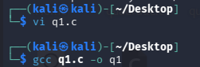
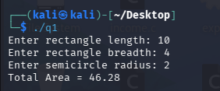
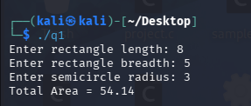
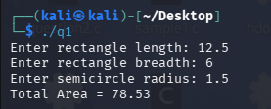
FOR QUESTION 2:
TEST CASE TABLE:
Test case | Input | Expected output | Actual outut | Result
1 | b=6, h=4, l=10, B=5 | 62.00 | 62.00 | Pass
2 | b=8, h=5, l=7, B=3 | 41.00 | 41.00 | Pass
3 | b=5.5, h=3, l=4.5, B=2 | 17.25 | 17.25 | Pass
ALGORITHM:
- Start
2. Declare b, h, L, B, triangleArea, rectangleArea and totalArea as real numbers.
3. Read b, h, L and B.
4. Calculate triangleArea = 0.5 x b x h.
5. Calculate rectangleArea = L x B.
6. Calculate totalArea = triangleArea + rectangleArea.
7. Display totalArea.
8. Stop
ALGORITHM EVALUATION: The algorithm correctly separates the two component areas and then adds them. All three prepared test cases produced actual outputs equal to the expected outputs, so the
program passes the test set.
C PROGRAM:
#include <stdio.h>

int main()
{
float base, height, length, breadth;
float triangleArea, rectangleArea, totalArea;

printf("Enter triangle base: ");
scanf("%f", &base);

printf("Enter triangle height: ");
scanf("%f", &height);

printf("Enter rectangle length: ");
scanf("%f", &length);

printf("Enter rectangle breadth: ");
scanf("%f", &breadth);

triangleArea = 0.5 * base * height;
rectangleArea = length * breadth;

totalArea = triangleArea + rectangleArea;

printf("Total Area = %.2f\n", totalArea);

return 0;
}
COMPILE, EXECUTE AND EVALUATE:
Compilation was performed with GCC. The program compiled successfully with no errors. It was the executed for each test case in Step 2. The actual outputs are shown in the test table and all test cases passed.
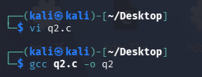
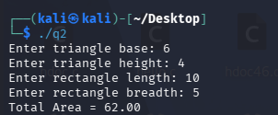
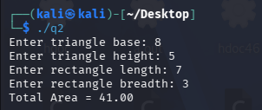
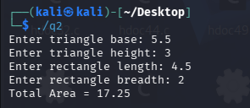
FINAL CONCLUSION:
Both C programs were compiled and executed successfully. For every prepared test case, the actual result matched the expected result. Therefore, both programs satisfy the stated requirements for
calculating the total area of their respective combined figures.

